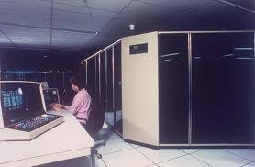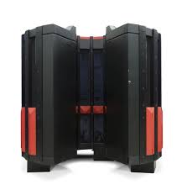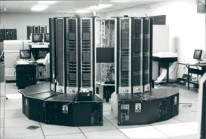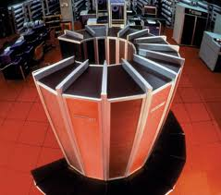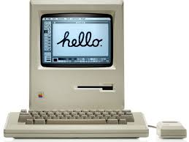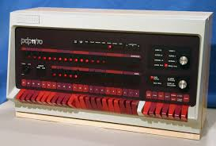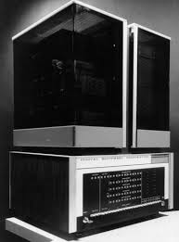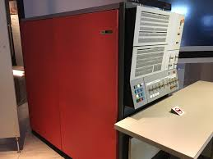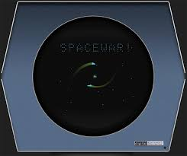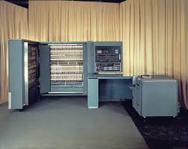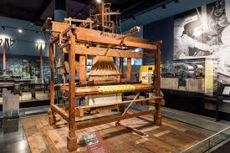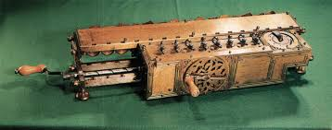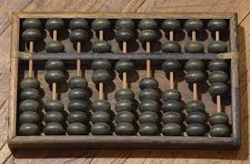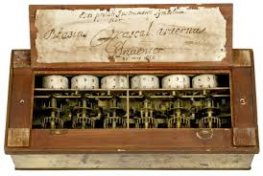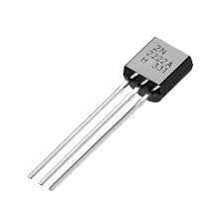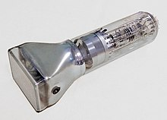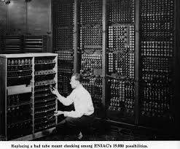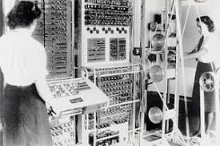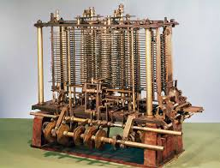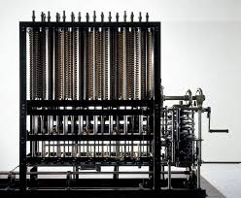

**TECH TIMELINE RESEARCH**

***INTRODUCTION TO COMPUTING***

**ACTIVITY #1**

INTRODUCTION TO COMPUTING

TECH TIMELINE RESEARCH

**During this time, there were super powerful computers that were really good at solving difficult math problems quickly. Most of the important work was still done by those super-fast computers.**

**PDP-11 DEC**

**PC & VLSI ERA (1972-PRESENT)**

**MACINTOSH**

**PDP-8 DEC**

**IBM 360 (1964)**

**This era introduced integrated circuits (ICs), which are small parts with many transistors. Microprogramming helped design complex processors, and pipelining improved processing speed. Operating systems and time-sharing began during this time.**

**INTEGRATED CIRCUIT ERA (1963-1972)**

SPACEWAR!

IBM 701 (1953)

**It was invented in 1947, and even several years later, it was considered by a scientific conference to be such an odd accomplishment that it was not included in the documentation.**

**TRANSISTORS ERA (1947-1962)**

**ANALYTIC ENGINE**

**PASCALINE**

**ENIAC**

**CATHODE RAY TUBE**

**TRANSISTORS**

**COLUSSUS**

**These machines used electronic switches, in the form of vacuum tubes, instead of electromechanical relays.**

**VACUUM CUBES ERA (1935-1946)**

**Computing machines invented on this generation entirely mechanical.**

**DIFFERENCE ENGINE**

**LOOMS**

**ABACUS**

**STEPPED RECKONER**

**MECHANICAL ERA (1642-1934)**